**Launching a Custom Image Windows AppStream Session.**

**Summary:-** We are creating this for the End User to Access all the UNO Bank websites & Tools inside this Virtual AppStream Session. Basically, whatever task need to be done respective to UNO Bank, need to do inside the AppStream.

**The Main Advantage of using the AppStream is:-**

* The User is having very less Access in the User Environment. They cannot install any of the Software or make any changes in windows setting.
* Admin can control everything from the admin console.
* If there is a requirement to install nay of the application in user console. Then they have to make a request to the Administrator.

**Top 6 Key Functionality used in AppStream.**

**Stack**

A *stack* consists of an associated fleet, user access policies, and storage configurations. You set up a stack to start streaming applications to users.

**Fleet**

A *fleet* consists of fleet instances (also known as streaming instances) that run the applications and desktops that you specify. Note that one user requires one instance.

**Image builder**

An *image builder* is a virtual machine that you use to create an image. You can launch and connect to an image builder by using the AppStream 2.0 console. After you connect to an image builder, you can install, add, and test your applications, and then use the image builder to create an image. You can launch new image builders by using private images that you own.

**Streaming instance**

A *streaming instance* (also known as a fleet instance) is an EC2 instance that is made available to a single user for application streaming. After the user’s session completes, the instance is terminated by EC2.

**User pool**

Use the *user pool* to manage users and their assigned stacks.

**Auto scaling rules**

*Auto scaling rules* are schedule-based and usage-based policies that you can apply to an Always-On or On-Demand fleet to automatically manage the number of streaming instances available for users to stream from.

If you open a AppStream, you will see this option on the left-hand side.

**How to create a Custom Image with Image builder.**

When you click on the **“Images”** on the lefthand side of the menu. You will see two option coming up. Below is the screenshot.

* In Image registry you will find all the images which are Public to all and the Images which you have created and for that the Visibility is Private and the owner is also the one who is creating the image.
* To create a New Custom Image, you need to click on **“Image Builder”.**
* Click on the  Button.
* Select the Base Image which you want. Like you want Windows or Amazon Linux, it will also depend on your work which image you want to choose. For me I just want to have Windows server with the latest version. So, I selected the below one.

* Click on Next.
* Give the Image Name and Display Name. (Both can be same)

* Select the Instance Type.

* As I told you I just have to add some application and use it. So, I’ll use the General-Purpose Instance.
* Click On Next.
* After that you need to configure the VPC for the Image.

* If you don’t have the VPC just Create it by clicking on the Link given and select it.
* Review all the setting which you have selected and click on .
* Go back to the Image Builder page and see the Image is listed out there.



* It will take 10 to 15 min to launch an image.
* After it Status is Running. Click on the image name.
* You will see the these option on the right top corner.
* Click on Connect.
* It will open a New Page and you will be connected to the Image which you created.
* On the very first time you will get the Option to select before connection to the image.

* So, with this console we can install any of the software & Setting in the Admin side and replicate it into the Users side as well.
* We have an application named Image Assistant on the admin side.
* If you need to add any kind of application which user can also use. For that you have to add it in the Image Assistant.

**How to add an application in the image and test it out for the end user.**

* Click on the **Image builder** which you created and click on **“Connect”.**
* Once you enter the Image builder, a screen will pop up and ask you in which user you want to enter.
* Click on Administrator side.
* You will see the Image Assistant Application on the desktop itself. Open it.
* What ever the Application you want to download like Chrome.
* In the Windows Server we have Firefox by default. Will open that and download the Chrome Setup file.
* After downloading it. Double Click on the setup file and install it in the Administrator side.

**Note:- While installing any of the Software make sure to copy the path or just remember the path where it is installing.**

**For Ex:-** Suppose, If I’m installing **“Win Merge”** in the admin side. Below is the Screenshot in which you can see the Path where the application is installing.

All the Application is installed in **Program Files** & **Program Files(*86).**

* After you Install the Application, in my case I’m installing WinMerge.
* Open the Image Assistant Application.

This application is already installed on the admin side as well as the user side . If you are staring fresh, you might see it bank.

* Click on the **“+ Add App”.**
* It will open the File Explorer and in that you need to open the same path which you have see while installing the software.

* After Click on Open. A New window will open. Below is the Screenshot.

* Click On Save. After this you can see your application will be added in your application list.

* Click On Next.

* If you read the 5 Steps given on the above Screenshot.
* It is asking to click on Switch user then go to the **Template User**  and open the application which you have installed and use it as you do normally.
* Then again open the Image Assistant in the **Template user**. And Click on the Switch user.
* And now you need to click on the **“Administrator User”.**
* You will see the same Image Assistant opened in the admin side.
* You can also see the Save setting button on that. (Refer the above Screenshot.)
* Click On the **Save Setting** button. It will take some time to save the setting.
* Click on **Next** after the setting is saved.
* And now again you need to click on **Switch User** and now we ned to click on **“Test User”** and open the application which you have installed and use it as you do normally.
* Then again open the Image Assistant in the **Test user** and Click on the Switch user. Now you are back to **Administrator user.**
* After you have tested the application in Template & Test user and come back to the Administrator user.
* Click On **Next**. Now you will see the below screen.

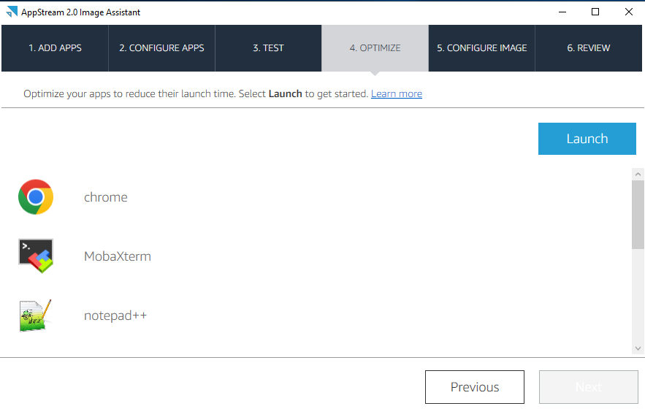

* You need to click on the Launch button. If will open all the application one by one.
* Their will be one dialog box which you need to click on when an application will open.

* Click on **Continue** if Chrome is opened. Same will happen will all the applications.
* After you opened all the application you need to click on **Next.** Then you will see below screen.

* Now you need to give the name of the Image. (Refer the Below Screenshot)

* You can give any name. I have given **Demo.** In Description you can add the application name or whatever changes you have mage in this new image.
* Click On **Next**.

* Click On **Disconnect and Create Image**.
* Now it will disconnect your session and it will create an image for you.

It will take approx. 15 min to create the Image.

* After the Creation of Image will be done. The status will automatically change to **Stopped.**
* You need to **Start** it manually.

If You open the Demo Image, you will see the Below Details.

**How we can Create a “*Fleets”* in AppStream.**

Click on the Fleets tab. On the right side you will see the Button of **Create Fleet.**

***Note:-*** *Whenever you are making any changes in Fleet. You must have to Restart the Fleet. To Incorporate all the Changes.*

* Click on Fleets, after that click on **Create Fleet**. A picture containing text

  Description automatically generated
* After that you will see Fleet Type.
* Select any of the Fleet type which suits your scenario. Click on Next.

Give the name of the Fleet and the same name will be in Display Name.

Select the Instance type as per the use case. You can also select the Dropdown and select the higher instance type with more vCPU’s & Memory.

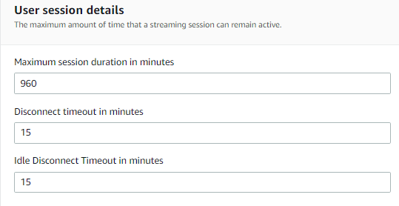

The Value which is By Default. If you have to change the Number, you can change it.

Disconnect time out is 15 Minutes. It means your session will be disconnected after 15 min if you are not using it.

Same with Idle Disconnect Timeout.

You need to mention the Minimum & Maximum count of how many users will be login in the AppStream. By Default, 1 Minimum & 4 Maximum user can login in AppStream.

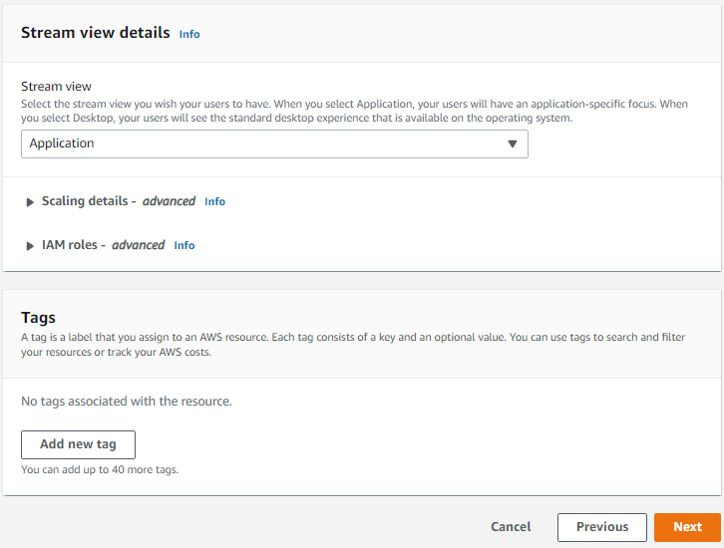

In Streaming view, you will see 2 option.

Application, Desktop

Rest All the Setting will be By Default.

Click on Next .

Total 21 images are there.

This will be next page here you can see the multiple Public & Private images.

The One which I selected is the one which we created with the help of image builder.

Private once will be the one which you have created.

Public image is already there by default.

**Note:-** If you need to enable this Default internet access, then for this you have to create a public subnet connected to the bastion host.

Here you need to select the VPC and the subnets and the Security Group.

If it is not created, then create it and refresh the with this button.

* Review all the setting which you have made and click on **Create Fleet**.
* Your Fleet will be upend running in sometime. (Refer below screenshot)

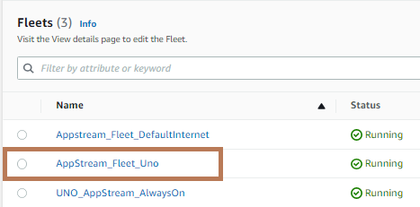

**How to create *“Stack”* in AppStream.**

When you click on the “Stack” on the lefthand side. You will see this Stack Details page. Where you need to give the name of the Stack.

And rest of the things will be optional.

Click on Next.

If you want an additional storage attached, then you can add **OneDrive or Google drive**. You just have to add the domain for OneDrive, and it will be there in your AppStream session.

By Default, this **Home folder** will be enabled. It will create a new S3 bucket for storing the data. If you want, you can disable it anytime after Creating the stack as well.

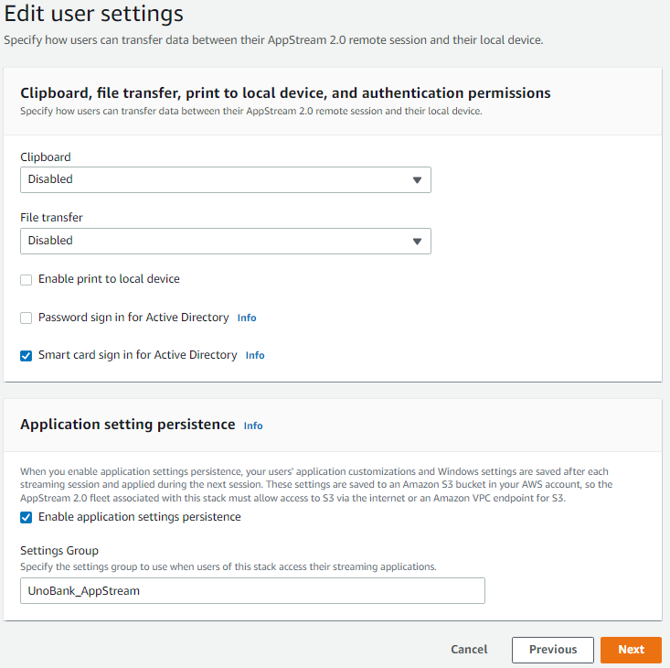

If you want to disable the copy paste access from outside into your AppStream Session, then you can Disable the Clipboard.

There is an option to upload and download file from out the AppStream Session then it can happen but if not then you can disable it in Stack.

Some More settings are their which you can enable or disable according to your requirement.

Click On Next.

* Review all the setting which you have made. If and changes required, then do it if not then Click on
* After creating the Stack. If you feel like you have to change some settings, then just go inside, and click on edit option in which section you need to edit.